ER Forward Run Tutorial: Two Buried Blocks

Overview
This example builds upon the mesh generation example shown in ERT1 Two Blocks example. The jupyter notebook numerical_solution_accuracy_example.ipynb takes the user through the steps in this tutorial. The file clear_files.ipynb resets the directory to contain files before running numerical_solution_accuracy_example.ipynb
This example is presented in two sections. In the first section, mode ERT2 is used to investigate numeric solution accuracy for the mesh by producing both the analytic and numeric solutions to the homogeneous halfspace problem. In the second section, a simulated survey is generated for a heterogeneous halfspace, and a selected potential field simulated for one of the survey measurements is visualized using VisIt.

Using Mode ERT2 to Investigate Numeric Solution Accuracy
The objective of this section is to demonstrate the use of mode ERT2 by comparing simulated survey results produced by the analytic and numeric solutions. We begin with the computational mesh and electrode configuration generated in the tutorial directory /mode_ERT1/two_blocks, which is shown in Figure 1 below.

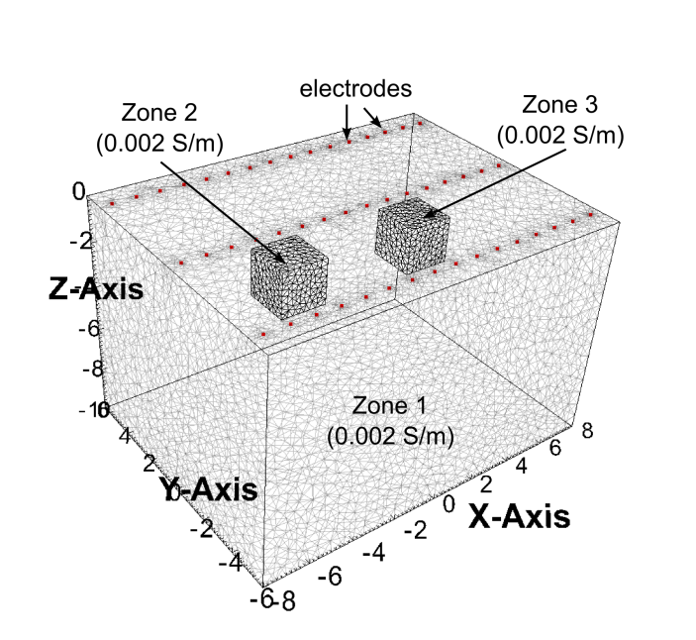
Figure 1. Zones 1-3 of computational mesh and electrode locations for the homogeneous conductivity case. Zone 4 extends to the outer boundary and is not shown,
After mesh construction, the files describing the mesh are located in two_blocks.1.node, two_blocks.1.ele, two_blocks.1.face, two_blocks.1.face, and two_blocks.trn. The conductivity file two_blocks.sig and the visualization files two_blocks.xmf, two_blocks.h5 were also produced by E4D as specified in the mesh configuration file for this example.

Survey File: two_blocks.srv
With the mesh and conductivity files constructed, the next step is to generate the survey file. The text below shows parts of the survey file used for this example, which includes a series of inline and cross-line dipole-dipole measurements.

<begin two_blocks.srv> (this line is not included in the file)

48 number of electrodes
1 -7.5 -5 0 1 eind ex ey ez eflag
2 -6.5 -5 0 1
3 -5.5 -5 0 1
.
.
.
46 5.5 5 0 1
47 6.5 5 0 1
48 7.5 5 0 1

2070 number of measurements
1 1 2 3 4 10.0 1.0 m_ind a b m n v_obs v_std
2 1 2 4 5 10.0 1.0 note: the v_obs and v_std are arbitrary placeholders in this example
3 1 2 5 6 10.0 1.0
.
.
.
1449 23 26 27 30 10.0 1.0 this potential distribution will be visualized in the next section
.
.
.
2068 30 46 31 47 10 1
2069 30 46 32 48 10 1
2070 31 47 32 48 10 1

<end two_blocks.srv> (this line is not included in the file)

Output Options File: two_blocks.out
Mode ERT2 also requires an output options file. The text below shows the output options used for this example. For this example, we instruct E4D to produce a simulated data file, and to name that file two_blocks.dpd. We also instruct E4D to build the potential distribution file for measurement 1449.

<begin two_blocks.out> (this line is not included in the file_

1 dp_flag = 1 to print simulated data file
two_blocks.dpd dp_file (name of simulated data file)
1 number of potential distribution files to construct
1449 index of measurement for which to produce potential distribution file
<end two_blocks.out> (note: this line is not included in the file)

Mode ERT2 e4d.inp
The final step before executing E4D is to construct e4d.inp. As demonstrated below, we will first execute E4D in analytic mode, and then produce the numeric solution. For the analytic mode, e4d.inp is:
<begin e4d.inp> (this line is not included in the file)
'ERTanalytic' run mode
two_blocks.1.node mesh node file name
two_blocks.srv survey file name
two_blocks.sig conductivity file name
two_blocks.out output options file name

<end e4d.inp> (this line is not included in the file)
The strategy here is to first run E4D in analytic mode to produce a simulated survey file that includes the analytic solution to the measurements specified in two_blocks.srv. The simulated survey file is then used for the the numeric solution. Because the survey file used for the numeric simulation contains the analytic solution results, the simulated data file produced by the numeric forward run will contain both the analytic and numeric simulation results for comparison. As directed in the output options file, the simulated data file name will be two_blocks.dpd. E4D will also produce the potential distribution file an_potential.1449 in analytic mode, potential.1449 in mode ERT2, the E4D log file e4d.log, and output to screen.

Analytic Simulation
With the input files created, E4D is executed by typing on the command line:
mpirun -np 1 e4d.
Note that slave processors are not utilized in analytic mode; the simulation is computed exclusively by the master process. Thus, only one processor is specified on the command line. If analytic mode is executed with more than one processor, the extra processors are not utilized.
Upon completion, E4D outputs several files as described above. A portion of the log file e4d.log is shown below for reference.
<begin e4d.log> (this line is not included in the file)

***************** RUNNING IN ERT ANALYTIC MODE ******************
Mode: Analytic
Mesh file: two_blocks.1.node
Survey configuration file: two_blocks.srv
Conductivity file: two_blocks.sig
Output options file: two_blocks.out
SURVEY FILE SUMMARY
Number of electrodes: 0000048
Number of measurements: 0002070
CONDUCTIVITY FILE SUMMARY
Number of conductivity values: 0000106405
MESH SUMMARY
Number of nodes: 0000018606
Number of metallic boundaries: 0000000000
Number of elements: 0000106405
Number of zones: 0000000004
.
.
.
WRITING POTENTIAL FILES
WRITING SIMULATED SURVEY FILE: two_blocks.sig.srv
Forward run complete.

<end e4d.log> (this line is not included in the file)

For this example, we are interested in the simulated survey file two_blocks.sig.srv, which contains the analytically simulated measurements. A portion of two_blocks.sig.srv is shown below.
<begin two_blocks.sig.srv> (this line is not included in the file)

48 note the electrode block is the same as the input survey file, two_blocks.srv
1 -7.5 -5 0 1
2 -6.5 -5 0 1
3 -5.5 -5 0 1
.
.
.
46 5.5 5 0 1
47 6.5 5 0 1
48 7.5 5 0 1

2070 the survey block contains the simulated measurement values
1 1 2 3 4 -26.5258 1.32629
2 1 2 4 5 -6.63145 0.331573
3 1 2 5 6 -2.65258 0.132629
.
.
.
2068 30 46 31 47 127.942 6.39710_ana
2069 30 46 32 48 50.0231 2.50116
2070 31 47 32 48 127.942 6.39710

<end two_blocks.sig.srv> (this line is not included in the file)

Numeric Simulation
To execute the numeric simulation, we first rename the simulated survey file to two_blocks_analytic.srv so that it is not overwritten during the numeric forward run. We then use two_blocks_analytic.srv as the survey file in the numeric forward run, so that the simulated data output file will report both the analytic and numeric measurement simulations. The e4d.inp file is first modified to be:

<begin e4d.inp> (this line is not included in the file)

ERT2 run mode is changed to from 'analytic' to 2 for numeric forward run
two_blocks.1.node mesh node file name
two_blocks_analytic.srv survey file name is changed to use the simulated survey file
two_blocks.sig conductivity file name
two_blocks.out output options file name

<end e4d.inp> (this line is not included in the file)

In mode ERT2, E4D requires at least 2 processors, and will utilize as many as ne+1 processors, where ne is the number of electrodes specified in the electrode block. In this case we use 7 processors to execute the forward run, which leaves 6 slave processors to compute the forward solutions. Since there are 48 electrodes, this leaves 8 electrodes per processor (or 8 pole solutions per processor, see E4D design guide). E4D is executed as:

mpirun -np 7 e4d

Upon completion, E4D outputs the simulated data file two_blocks.dpd, a portion of which is shown below. Column 1 shows the measurement index, columns 2-5 show the "a b m n" electrode indexes for each measurement, column 6 shows the analytically simulated measurement, and column 7 shows the numerically simulated measurements.

<begin two_blocks.dpd> (this line is not included in the file)

2070
1 1 2 3 4 -26.5258 -25.2777
2 1 2 4 5 -6.63145 -6.51073
3 1 2 5 6 -2.65258 -2.67544
4 1 2 6 7 -1.32629 -1.32612
5 1 2 7 8 -0.757881 -0.761162
.
.
.

<end two_blocks.dpd> (this line is not included in the file)

